****TO SUPPLY LEFTOVER FOOD TO POOR****

**College Name:AG ARTS AND SCIENCE COLLEGE**

**College Code:bru5r**

**TEAM ID:NM2025TMID**

Team leader:isna

Email:isnasajahan@gamil.com

**Team Member1:hemalatha**

**Email: hemalatha11005**

**Team Member2:jayaprabha**

**Email: jayaprabha1415**

Team Member3:harish

Email:harishcgp159@gmail.com

****1.INTRODUCTION****

****1.1 Project Overview****

**In Salesforce, supplying leftover food to the poor can be managed as a CSR(Corporate Social Responsibility) initiative where organization use Salesforce’s Nonprofit Cloud or Service Cloud to track food donations, connect donors (restaurants, events, etc.) with volunteers, amd manage distribution to beneficiaries efficiently.**

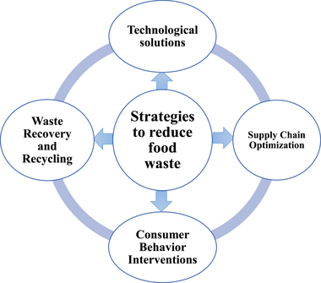

****1.2 Pupose****

**In Salesforce, the purpose of supplying leftover food to the poor is to use Salesforce tools (like Nonprofit Cloud) to track food donations, manage volunteers, and streamline distribution so surplus food reaches needy people efficiently.**

**SALESFORCE DEVELOPER ACCOUNT CREATION**

### **Creating Developer Account**:

### By using this URL - [**https://developer.salesforce.com/signup**](https://developer.salesforce.com/signup)

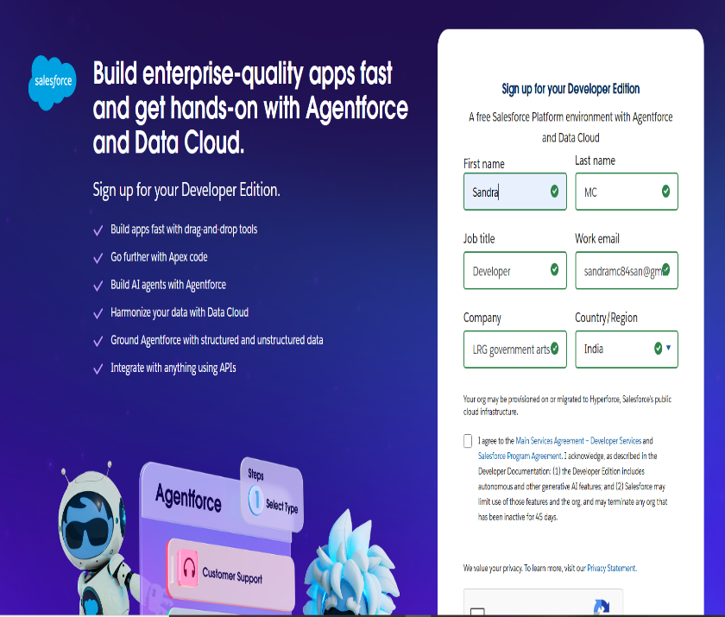

* **Creating objects: Venue, Drop-off points, Task, Volunteer, Execution Details.**

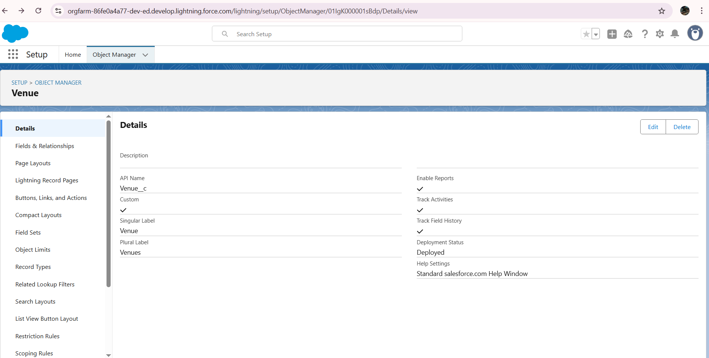

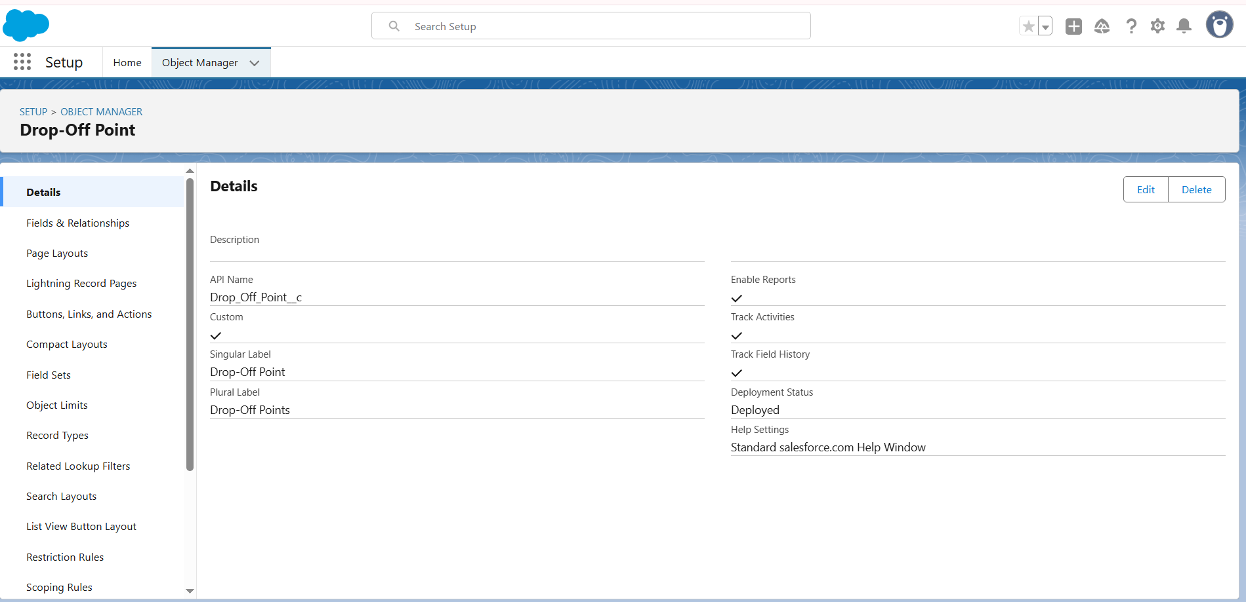

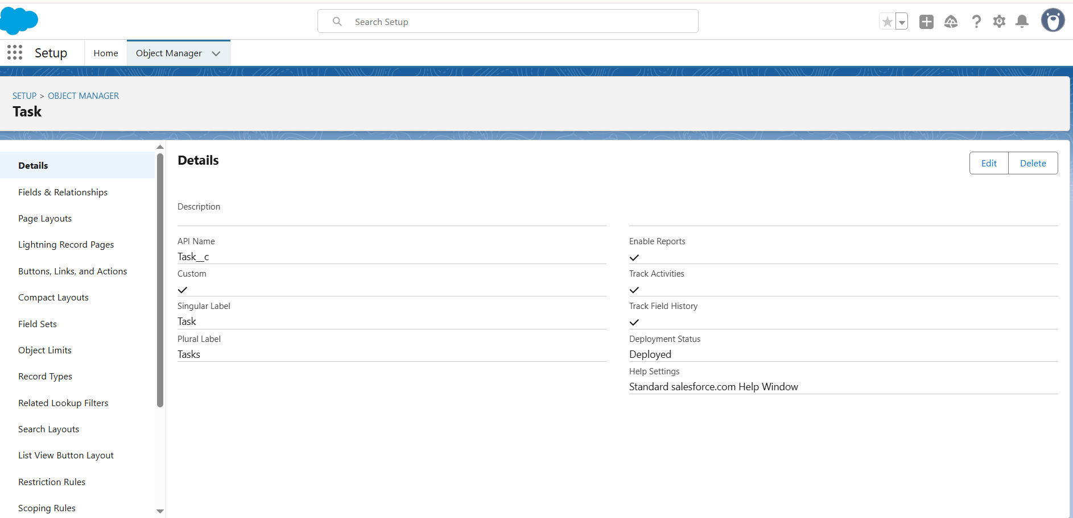

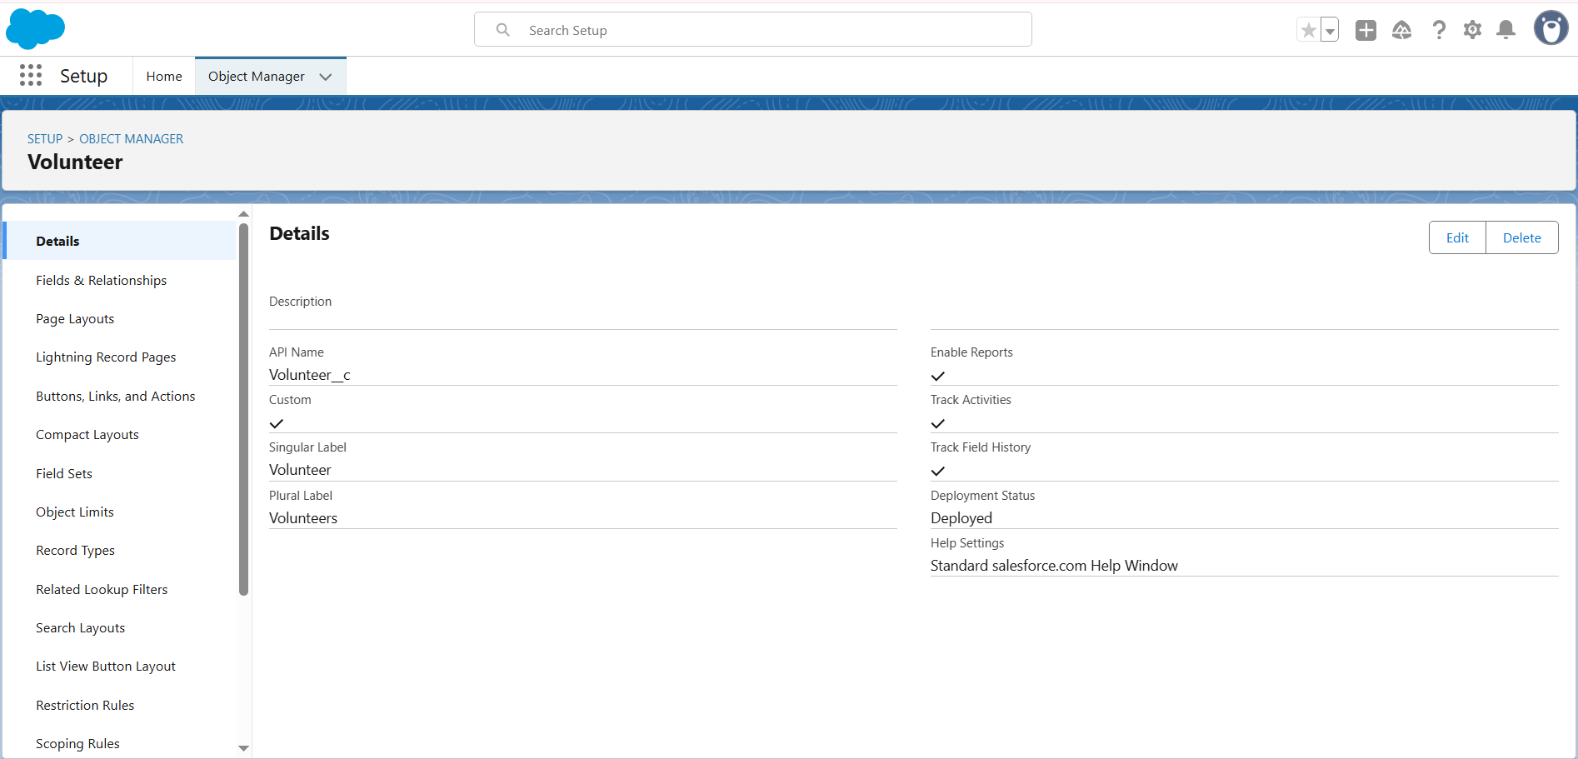

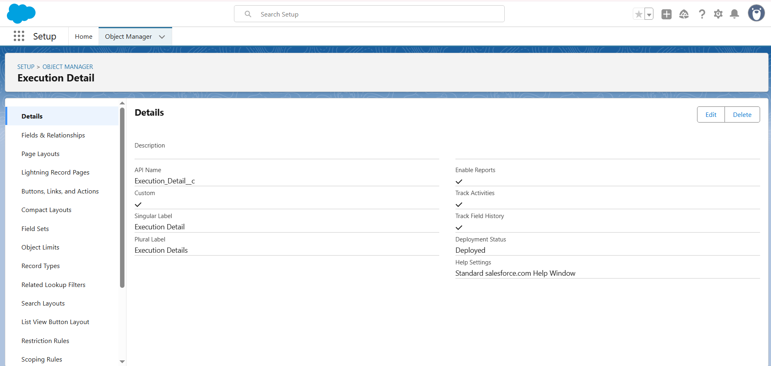

### Creating a CustomTab: Venue, Drop-Off Point, Task, Volunteer, Execution Details.

### 

### Create a Lightning App

### 

### 

### 

### 

### Creation of Fields: Relationship, Venue, Drop-Off Point, Task, Volunteer, Execution Details.

### 

### 

### 

### 

### 

### 

### Create Flow to create a record in Venue object

### 

### 

### Create a Trigger

### 

### 

### Creation of profiles

### 

### Creation of User

### 

### 

### 

### Creation of Public Groups

### 

### Creation of Report Types

### 

### Creation of Report : Venue with DropOff with Volunteer, Volunteers with Execution Details and Tasks

### 

### Adding venue and Drop Off point Report, Volunteer Task Report to the Dashboard

### 

### Creation of sharing rules

### 

### Creation of Home Page

### 

### **CONCLUSION:**

### In Salesforce, the purpose of supplying leftover food to the poor is to use Salesforce tools (like Nonprofit Cloud) is to track food donations, manage volunteers, and streamline distribution so surplus food reaches needy people efficiently.